Multiple-choice section

|  |  |  |  |  |  |  |  |  |  |  |  |  |
| --- | --- | --- | --- | --- | --- | --- | --- | --- | --- | --- | --- | --- |
| Question | 1 | 2 | 3 | 4 | 5 | 6 | 7 | 8 | 9 | 10 | 11 | 12 |
| Answer | A | B | D | C | B | C | A | D | B | C | C | A |

Question 1 [7.1]

A

2*n* + 3 = 22

Question 2 [7.1]

B

2*a* − 5 = -11

LHS = 2(-3) − 5

LHS = -6 − 5

LHS = -11

LHS = RHS

 *a* = -3

Question 3 [7.2]

D

13 − 2*x* = 5

-2*x* = 5 − 13

-2*x* = -8

*x* = 

*x* = 4

Question 4 [7.2]

C

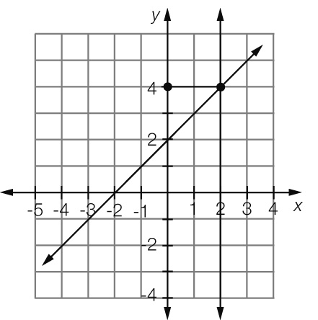

Where *x* = 2, *y* = 4

Question 5 [7.2]

B

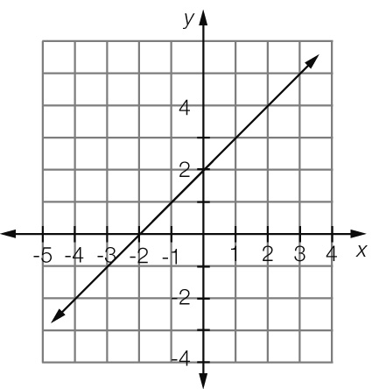

Where *y* = 0, *x* = -2

Question 6 [7.2]

C

To obtain *x* ‘add 6 and multiply by 3’.

Question 7 [7.4]

A

4*x* + 4 = 3*x* + 6

*x* + 4 = 6

*x* = 2

Question 8 [7.3]

D

 + 5 = 2

 = 2 − 5

= -3

*b* = -3 × 4

*b* = -12

Question 9 [7.3]

B

3(*x* − 6) = 21

3*x* − 18 = 21

3*x* = 21 + 18

3*x* = 39

*x* = 13

Question 10 [7.4]

C

5*d* − 2 = 2*d* + 6

5*d* − 2*d* − 2 = 6

3*d* = 6 + 2

3*d* = 8

*d* = 

*d* = 2

Question 11 [7.4]

C

*x* − 3 = 4*x* − 9

-3 = 4*x* − *x* − 9

-3 = 3*x* − 9

-3 + 9 = 3*x*

6 = 3*x*

*x* = 2

Question 12 [7.5]

A

4*C* + 0.60 = 5.00

4*C* = 5.00 – 0.60

4*C* = 4.40

*C* = 

*C* = 1.10

Each chocolate bar was $1.10.

Multiple-choice total marks: 12

Short answer section

Question 13 3 marks [7.3]

(a) David’s working  
 − 5 = 7  
  = 12



(b) Correct working   
 − 5 = 7  
  = 12  
 *x* = 36

(c) David divided by 3 rather than multiplying by 3.

Question 14 3 marks [7.2]

The taxi costs $5 to hire before you go anywhere (‘flagfall’ = $5).

For 10 km the taxi charges an additional $20.

Thus the taxi charges $2 per km.

The total cost for the taxi journey can be given by the equation *c* = 2*d* + 5, where *c* is the cost and *d* is the distance in km.

Question 15 4 marks [7.1]

(a) 2*n* + 4 = 22

(b) *n* + 5 = 2*n* − 3

Question 16 6 marks [7.1]

(a) 3*x* − 5 = 13 (*x* = 6)  
LHS = 3 × 6 − 5  
= 18 − 5   
= 13  
= RHS  
Thus *x* = 6 is a solution.

(b) = 20 (*x* = 4)  
LHS =   
≠ RHS  
Thus *x* = 4 is *not* a solution.

(c) ****= -1 (*x* = -1)  
LHS = ****= 

≠ RHS  
Thus *x* = -1 is *not* a solution.

Question 17 2 marks [7.1]

2(*m* − 2) = 10

A number has two subtracted from it and the result is doubled. This result equals ten.

Question 18 4 marks [7.1]

(a) *F* = *Ma* (b) *R* = 2*B* − 5

Question 19 2 marks [7.2]

3*x* + 7 = 1

3*x* = 1 – 7

3*x* = -6

*x* = -2

Question 20 4 marks [7.2]

(a) 3*c* + 5 = 4  
3*c* = 4 − 5  
3*c* = -1  
*c* = 

(b) 17 + 4*b* = -33  
4*b* = -33 − 17  
4*b* = -50  
*b* =*****b* = 

Question 21 4 marks [7.2]

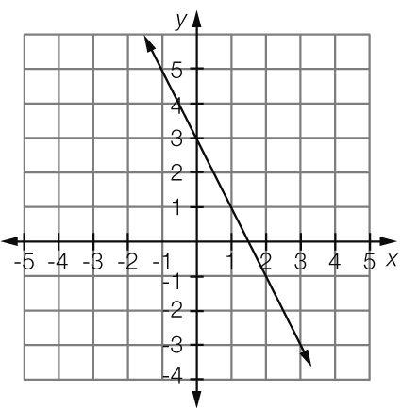

(a) Where *x* =, *y* = -2 (b) Where *x* = -2, *y* = 7

(c) Where *y* = 3, *x* = 0 (d) Where *y* = 0, *x* = 

Question 22 4 marks [7.2]

(a) 3*a* − 5 = -17  
3*a* = -17 + 5  
3*a* = -12  
*a* = *****a* = -4

(b) 23 + 4*b* = 5  
4*b* = 5 − 23  
4*b* = -18  
*b* =*****b* = 

Question 23 4 marks [7.2]

(a) 2*x* − 5.6 = 7.2  
2*x* = 7.2 + 5.6  
2*x* = 12.8  
*x* =   
*x* = 6.4

(b) ****+ 3*x* = ****8 + 9*x* = 10  
9*x* = 2  
*x* = 

Question 24 4 marks [7.2]

(a) 5 − 4*x* = -15  
-4*x* = -15 − 5  
-4*x* = -20  
*x* =   
*x* = 5

(b) -3 − 2*m* = 9  
-2*m* = 9 + 3  
-2*m* = 12  
*m* =   
*m* = -6

Question 25 3 marks [7.2]

Let the cost of a coffee be represented by the letter *c* and a sandwich by the letter *r*.

∴ 5*c* + 2*r* = 26.5

5*c* + 2(4.5) = 26.5

5*c* + 9 = 26.5

5*c* = 17.5

*c* = 

*c* = 3.5

Thus the cost of a cup of coffee was $3.50.

Question 26 6 marks [7.3]

(a) = 7  
2*x* − 3 = 7 × 5  
2*x* − 3 = 35  
2*x* = 38  
*x* =   
*x* = 19

(b) + 8 = 5  
= 5 − 8  
= -3  
 3*x* = -3 × 4  
 3*x* = -12  
 *x* =   
 *x* = -4

Question 27 9 marks [7.3]

(a) 3(*x* − 5) = 21  
3*x* − 15 = 21  
3*x* = 21 + 15  
3*x* = 36  
*x* =   
*x* = 12

(b) 4(3*x* + 2) = 24  
12*x* + 8 = 24  
12*x* = 24 − 8  
12*x* = 16  
*x* =   
*x* =    
*x* = 1

(c) 5(2*c* − 3) = 22  
10*c* − 15 = 22  
10*c* = 22 + 15  
10*c* = 37  
*c* =   
*c* = 3

Question 28 6 marks [7.3]

(a) 2*n* − 6 = 8  
2*n* = 8 + 6  
2*n* = 14  
*n* =   
*n* = 7  
Thus the number is 7.

(b) 3(*n* − 3) = 18  
3*n* – 9 = 18  
3*n* = 18 + 9  
3*n* = 27  
*n* =   
*n* = 9  
Thus the number is 9.

Question 29 4 marks [7.3]

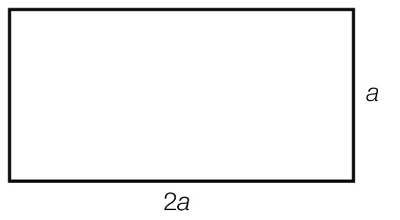

Let *a* be the length of the shorter sides of the pen

length of the longer sides of the pen = 2*a*

perimeter of pen = *a* × 2 + 2*a* × 2

420 = *a* × 2 + 2*a* × 2

420 = 2*a* + 4*a*

6*a* = 420

*a* = 

*a* = 70

So the dimensions of the fenced pen are 70 m by 140 m.

Question 30 3 marks [7.4]

Let the weight of a coin = *c*

7*c* + 3*x* = 5*c* + 5*x*

3*x* = 5*c* − 7*c* + 5*x*

3*x* = -2*c* + 5*x*

3*x* − 5*x* = -2*c*

-2*x* = -2*c*

*x* = 

*x* = *c*

*x* is the same weight as one of the coins.

Question 31 9 marks [7.4]

(a) 5*x* − 4 = 2*x* + 5  
5*x* – 2*x* – 4 = 5  
3*x* = 5 + 4  
3*x* = 9  
*x* = 3

(b) 3*x* + 4 = 8*x* − 11  
4 = 8*x* − 3*x* − 11  
4 = 5*x* − 11  
4 + 11 = 5*x*5*x* = 15  
*x* = 3

(c) 2*x* + 5 = 7*x* − 6  
5 = 7*x* – 2*x* – 6  
5 = 5*x* − 6  
5 + 6 = 5*x*   
5*x* = 11  
*x* =   
*x* = 2

Question 32 6 marks [7.4]

(a) 3*x* − 6 = 2(*x* + 5)  
3*x* – 6 = 2*x* + 10  
3*x* − 2*x* – 6 = 10  
*x* = 16

(b) 6(*x* + 2) = 2(1 − 2*x*)  
6*x* + 12 = 2 − 4*x*6*x* + 4*x* + 12 = 2  
10*x* = 2 – 12  
10*x* = -10  
*x* = -1

Question 33 9 marks [7.4]

(a)  =   
2(2*x* − 3) = 5(3*x* + 1)  
4*x* − 6 = 15*x* + 5  
-6 = 15*x* – 4*x* + 5  
*-*6 *=* 11*x +* 5  
11*x = -*11  
*x = -*1

(b)  =   
5(3 − *x*) = 3(1 − 2*x*)  
15 − 5*x* = 3 − 6*x*15 − 5*x* + 6*x* = 3  
15 + *x* = 3  
*x* = 3 − 15  
*x* = -12

(c) 2*x* + 4 − 5 = 3*x* + 1  
2*x* − 1 = 3*x* + 1  
-1 = 3*x –* 2*x +* 1  
-1 = *x +* 1  
*x* = -2

Question 34 6 marks [7.4]

(a) 2 − *x* = *x*

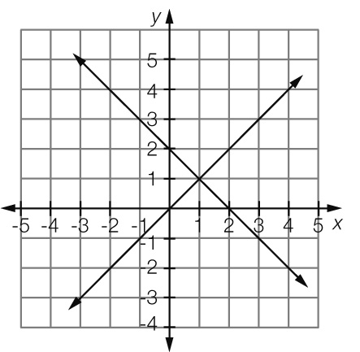

*x* = 1

(b) 3*x* + 5 = 1 − *x*

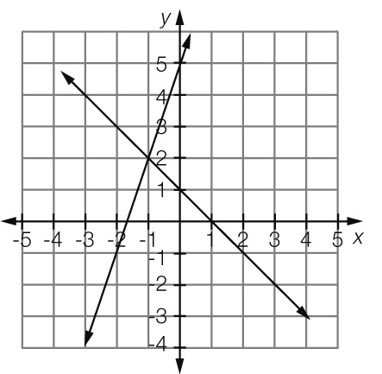

*x* = -1

Short answer total marks: 105

Extended answer section

Question 35 9 marks [7.2, 7.3, 7.5]

(a) 5000 ÷ 500 = 10. Or, using the graph, at Time = 10, Volume = 0.  
It takes 10 minutes for the bucket to empty.

(b) Volume of water in the bucket by time

(c) Initial volume of water in the bucket is 5000 mL.

(d) 5000 − 3500 = 1500  
1500 ÷ 500 = 3  
After 3 minutes there is 3500 mL left in the bucket.

(e) 4 × 500 = 2000  
5000 − 2000 = 3000  
After 4 minutes there is 3000 mL left in the bucket.

(f) 7 × 500 = 3500  
5000 − 3500 = 1500  
After 7 minutes there is 1500 mL left in the bucket.

(g) 8 × 500 = 4000  
After 8 minutes 4000 mL has leaked from the bucket.

(h) *V* = 5000 − 500*t*; Dis the correct equation for the graph.

(i) 2 × 500 = 1000  
5000 ÷ 1000 = 5  
If the leakage rate doubled, it would take 5 minutes for the bucket to empty.

Question 36 6 marks [7.1, 7.2, 7.5]

(a) *C* = 0.5 + 0.12 × 6 × *n  
C* = 0.5 + 0.72*n*

(b) *C* = 0.5 + 0.72 × 11  
*C* = 0.5 + 7.92  
*C* = $8.42

(c) *C* = 0.5 × 5 + 0.72 × 50  
*C* = 2.50 + 36  
*C* = $38.5

(d) Total charges = calls + texts   
= 213 + 793 × 0.22  
= 213 + 174.46  
= $387.46  
Bill cost   
= (387.46 − 350) + 35  
= 37.46 + 35  
= $72.46

Question 37 9 marks [7.1, 7.2, 7.5]

(a) *J* = *K* + 10

(b) *J* = *C* − 20

(c) *K* + 10 = *C* − 20  
*K* = *C* − 20 − 10  
*K* = *C* − 30

(d) *C* − 30 = *K  
C* − 30 + 30 = *K* + 30  
*C* = *K* + 30

(e) *C* = 2*K* + 5

(f)

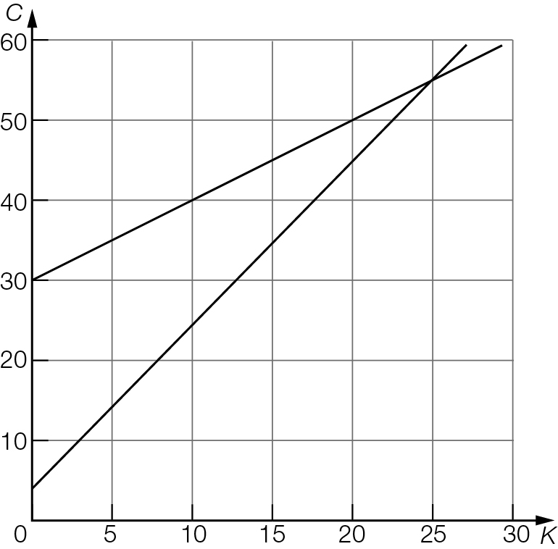

Kerry is 25 years old, Cassandra is 55 years old.

(g) Jarod is 35 years old.

Extended answer total marks: 24

TOTAL test marks: 141